7.39 Main Question (สำหรับแสดงข้อสอบ)

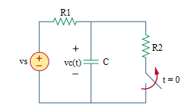

Given *vs* = 20 V, *R*1 = 4 Ω, *R*2 = 1 Ω, *C* = 2 F.

Find

Variables (สำหรับเขียนโค้ดเพื่อหาคำตอบ)

Random variables

vs = {10:40};

r1 = {1:100};

r2 = {1:100};

c = {1:10};

time = {1:10};

Global variables

# vs = 20; r1 = 4; r2 = 1; c = 2; time = 1;

vc0 = (r2*vs)/(r1+r2);

vcinf = vs;

tau = r1*c;

vct = vcinf +(vc0- vcinf)*exp(-time);

Part (กรอกคำตอบ)

1. vc(0-) = vc0 = 4 V
2. vc(0+) = vc0 = 4 V
3. vc(inf) = vcinf =20 V
4. τ = tau = 8 s

At t>0

1. vc(t) = vcinf+(vc0-vcinf)*exp(-t/tau) = 20-16*exp(-t/8) V
2. vc(timeτ) = vct = 19.63 V

7.40 Main Question (สำหรับแสดงข้อสอบ)

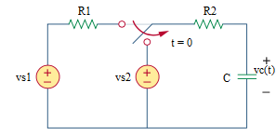

Given *vs*1 = 12 V, *vs*2 = 4 V, *R*1 = 3 Ω, *R*2 = 2 Ω, *C* = 3 F.

Find

Variables (สำหรับเขียนโค้ดเพื่อหาคำตอบ)

Random variables

vs1 = {10:40};

vs2 = {10:40};

r1 = {1:100};

r2 = {1:100};

c = {1:10};

time = {1:10};

Global variables

# vs1 = 12; vs2 = 4; r1 = 3; r2 = 2; c = 3; time = 1;

vc0 = vs1;

vcinf = vs2;

tau = r2*c;

vct = vcinf +(vc0- vcinf)*exp(-time);

Part (กรอกคำตอบ)

1. vc(0-) = vc0 = 12 V

2. vc(0+) = vc0 = 12 V

3. vc(inf) = vcinf = 4 V

4. τ = tau = 6 s

At t>0

5. vc(t) = vcinf+(vc0-vcinf)*exp(-t/tau) = 4+8*exp(-t/6) V

6. vc(timeτ) = vct =6.94 V

7.40b Main Question (สำหรับแสดงข้อสอบ)

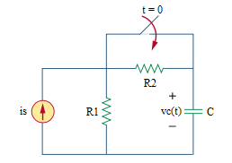

Given *is* = 6 A, *R*1 = 2 Ω, *R*2 = 4 Ω, *C* = 5 F.

Find

Variables (สำหรับเขียนโค้ดเพื่อหาคำตอบ)

Random variables

is = {1:40};

r1 = {1:100};

r2 = {1:100};

c = {1:10};

time = {1:10};

Global variables

# is = 6; r1 = 2; r2 = 4; c = 5; time = 1;

vc0 = is*r1;

vcinf = is*r1;

tau = r1*c;

Part (กรอกคำตอบ)

1. vc(0-) = vc0 = 12 V

2. vc(0+) = vc0 = 12 V

3. vc(inf) = vcinf = 12 V

4. τ = tau = 10 s

At t>0

5. vc(t) = vcinf +(vc0- vcinf)*exp(-t/tau) = 12 V

6. vc(timeτ) = 12 V

7.46 Main Question (สำหรับแสดงข้อสอบ)

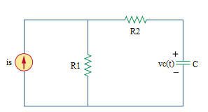

Given *is* = 5u(t) A, *R*1 = 6 Ω, *R*2 = 2 Ω, *C* = 0.25 F.

Find

Variables (สำหรับเขียนโค้ดเพื่อหาคำตอบ)

Random variables

r1 = {1:100};

r2 = {1:100};

c = {0.25:5:0.25};

time = {1:10};

Global variables

# r1 = 6; r2 = 2; c = 0.25; time = 1;

vc0 = 0;

vcinf = 5*r1;

tau = (r1+r2)*c;

vct = vcinf +(vc0- vcinf)*exp(-time);

Part (กรอกคำตอบ)

1. vc(0-) = vc0 = 0 V

2. vc(0+) = vc0 = 0 V

3. vc(inf) = vcinf = 30 V

4. τ = tau = 2 s

At t>0

5. vc(t) = vcinf +(vc0- vcinf)*exp(-t/tau) = 30-30*exp(-t/2) V

6. vc(timeτ) = vct = 18.96 V

7.48 Main Question (สำหรับแสดงข้อสอบ)

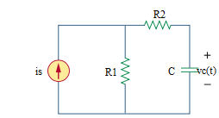

Given *is* = u(-t) A, *R*1 = 10 Ω, *R*2 = 20 Ω, *C* = 0.1 F.

Find

Variables (สำหรับเขียนโค้ดเพื่อหาคำตอบ)

Random variables

r1 = {1:100};

r2 = {1:100};

c = {0.1:1:0.1};

time = {1:10};

Global variables

# r1 = 10; r2 = 20; c = 0.1; time = 1;

vc0 = r1;

vcinf = 0;

tau = (r1+r2)*c;

vct = vcinf +(vc0- vcinf)*exp(-time);

Part (กรอกคำตอบ)

1. vc(0-) = vc0 = 10 V

2. vc(0+) = vc0 = 10 V

3. vc(inf) = vcinf = 0 V

4. τ = tau = 3 s

At t>0

5. vc(t) = vcinf +(vc0- vcinf)*exp(-t/tau) = 10*exp(-t/3) V

6. vc(timeτ) = vct = 3.67 V